Vashi Electricals launches their eCommerce portal for users
A basket of products under one roof to meet project or emergency maintenance requirements!

Mumbai, 27th October 2017: Vashi Electricals, one of the India’s largest channel partner has launched an ecommerce portal under its flagship brand name, www.vashielectricals.com, for its consumers and businesses to shop on the web. Through its portal it has began selling motors, wires and cables, switchgears, gearboxes, motors and allied electrical products online.
The e-commerce portal was launched in an exclusive event held in the Vashi Electricals Corporate Office based in Mumbai. The event was graced by the top management from Hindustan Motors, Kishore bhai & Siddharth Desai along with other senior executives from premier industrial electrical brands such as Polycab, ABB, Siemens, Omron & Connectwell. Along with these, the event was also graced by Vashi Electrical’s key customers and press members, alike.
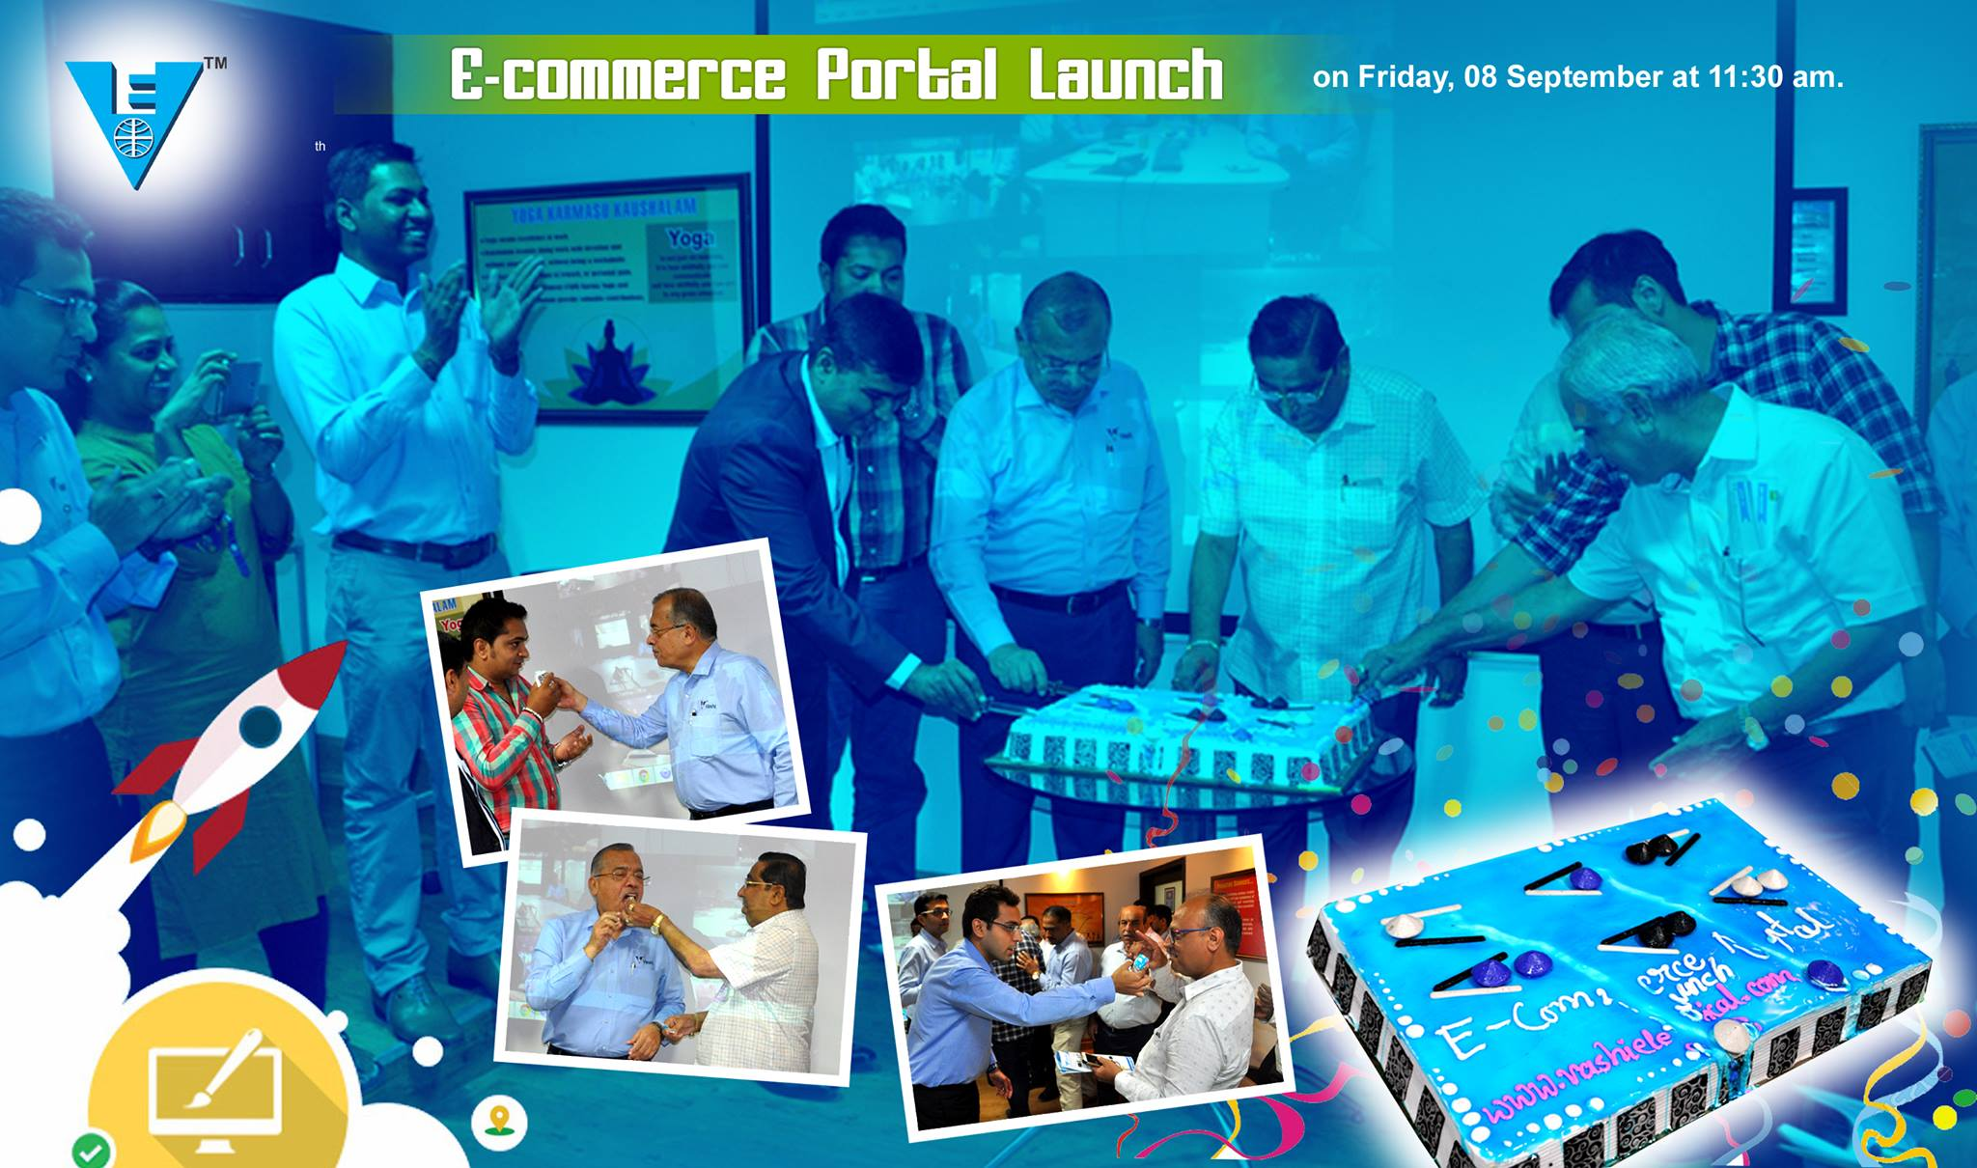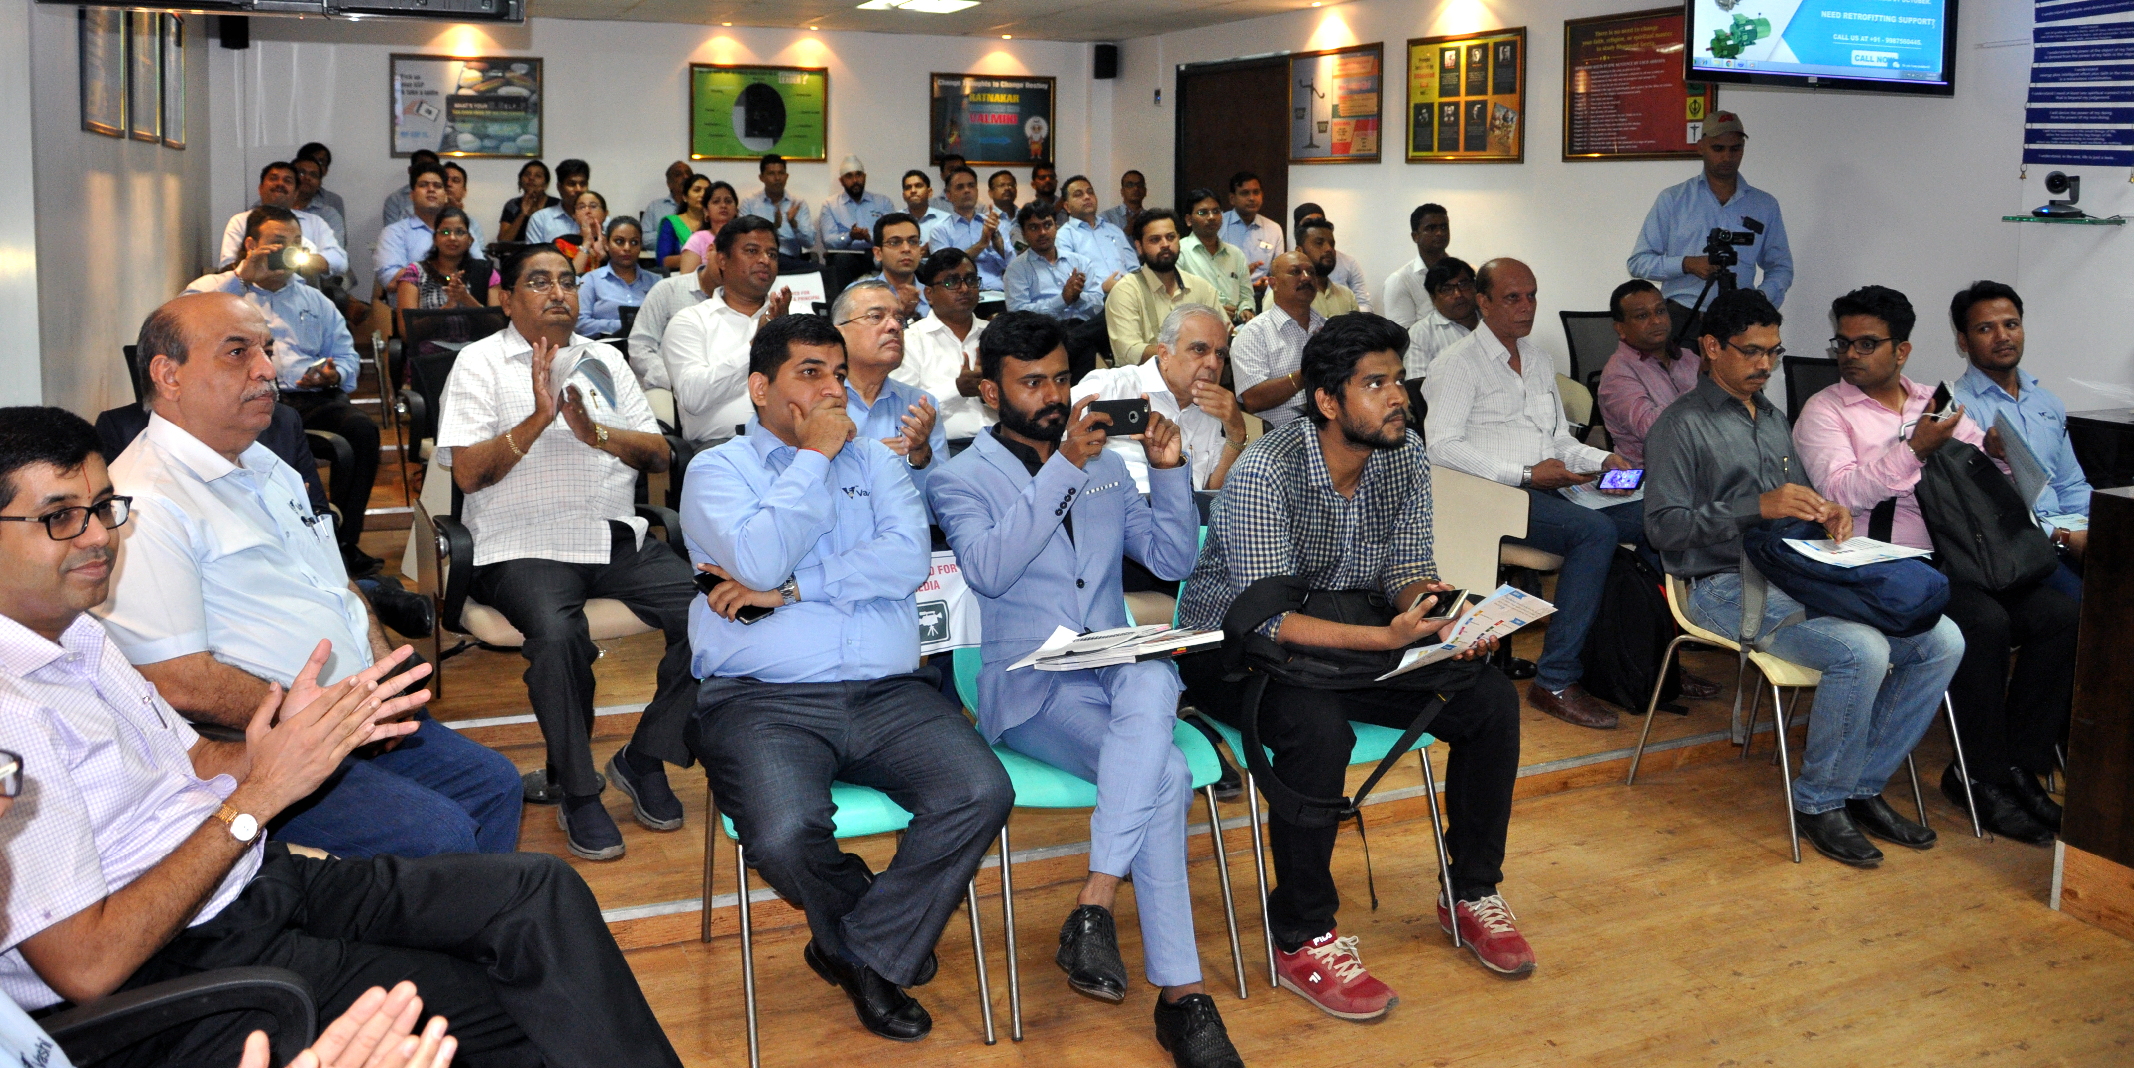
The Launch Event at the Vashi Electricals Corporate Office, based in Mumbai.

Initially, Vashi Electricals.com will sell around 15,000 SKU’s from 15 different electrical brands however the expansion plan is to add more than 100,000 SKU’s and premier electrical brands in the next 01 year, said one of the key executives from the company.
Madan Dodeja, CEO of Vashi Electricals said that ‘Our Idea of e-commerce is to offer delightful experience to the Vashi Customers’ and offer a seamless purchase experience for consumers, and ensure that consumer gets genuine product. Our commitment of 72 hours flat delivery will ensure that the logistics is handled meticulously and our PAN India warehouses will help in achieving it”.
Talking about the Technology, Suraj Dodeja, Director of Vashi Electricals commented that, “To gain an competitive advantage among B2B players, we will focus more on innovative solutions such as chat-bots, real-time stock discovery & smart-watch notifications that help ensure us to stay close with the clients’ needs and optimize in a digital way.
Answering one of the marketing questions asked by a customer, Ganesh Gupta, Online Marketing Lead of Vashi Electricals said, “Initially we will focus on on-boarding all our offline customers into online stream and ensure they are comfortable in making transactions. We would also mine data through Google, Magento & In-search analytics and ensure that we are employing right marketing strategies so that the customer or user has a delightful user experience on the portal. Road-show is one of the strategies we are considering to reach to industrial towns of the country.”The e-commerce market is anticipated to be worth $22 billion in the next five years, from $3.1 billion, according to a November 2013 report by CLSA.
About Vashi Electricals
Vashi Electricals Pvt. Ltd. the largest Channel Partner of Reputed International Brands of Industrial Products Celebrates 39 Golden Years of Service to the Electrical trade. Incepted in 1978, this family business with a humble beginning and King size dreams initiated the change in pattern of response and service to the customer. The business process designed was committed to service customers in time. Focused Commitment and Efforts resulted in manifold Growth and Expansion of network.

