“The safety and comfort together with the reliability of the buses were our key criteria in deciding to purchase 16 nos. BharatBenz AC school buses” -- Inventure Academy

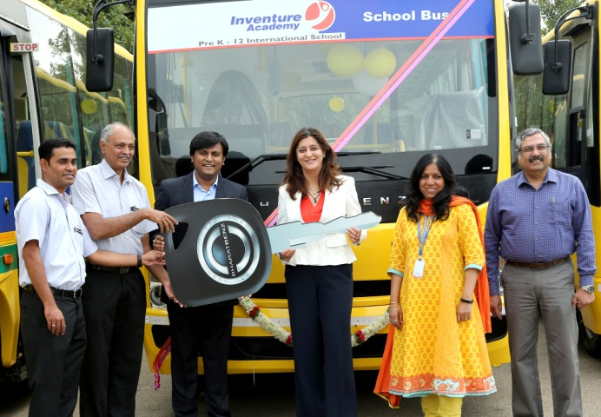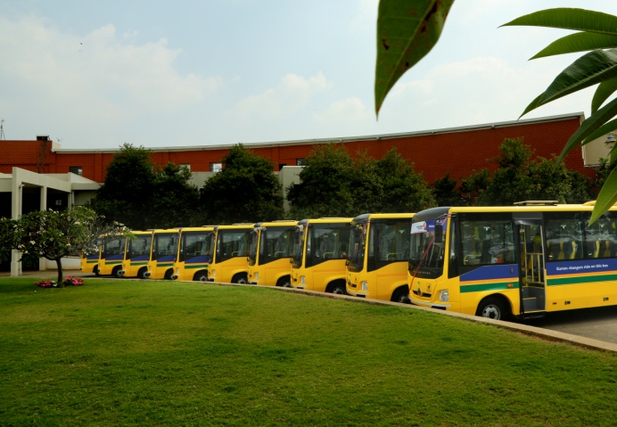
Key hand over of 16 nos. Bharat Benz BS4 AC School bus to Inventure Academy,
Ms Nooraine Fazal—Managing Trustee & CEO by Mr Shashank Mehta—RM, Daimler India, Bus and Sudarshan – CEO, Trident Automobiles.

Inventure Academy has recently bought 16 BharatBenz AC school buses to ensure students and faculty have a comfortable and safe journey to and from school. The Bharat Benz buses were finalised after a demo of the bus’ unique features and comfort was provided to students and faculty.

“In keeping with Inventure’s Core Value of Encouraging Sensitivity, we have taken into account the long distances that faculty and students travel to and from school everyday. The safety and comfort together with the reliability of the buses were our key criteria in deciding to purchase the BharatBenz AC school buses. In addition, the fuel efficiency of the buses aligns to the school’s pledge towards environmental sustainability and lower costs.” – Inventure Academy

Inventure Academy is an international day school located on the Whitefield-Sarjapur Road, Bangalore. It offers top of the class quality education and facilities from Kindergarten to Senior Secondary (PreK-12) at a relatively affordable cost. It is affiliated to the Cambridge International Examinations (CIE) and the Council for the Indian School Certificate Examinations (CISCE). Spread over 30 acres, the school is committed to providing high quality academic curricula along with varied beyond academics activities to ensure that education at Inventure Academy is not only fun, but well – balanced and challenging, fostering a Passion for Excellence and Dynamism in every member of Team Inventure.

In the words of Aditi, a senior faculty who travels 35 kms to and fro every day, “The BharatBenz buses are definitely more than a notch above and beyond any of the buses we have travelled in, to and from school thus far.”

Ryaan Rehman, senior school student and Sports Captain, who commutes all the way from Richards Town, shared his experience with us, “ The journey on the BharatBenz bus was definitely more comfortable than the bus I currently travel on. The seats are better spaced, providing ample legroom and the ride was comfortable even over roads bumps and potholes. My commute back and forth takes at least 3 hours everyday, but the long commute home did not feel tiring on the new bus. I have after school soccer on at least twice a week and a comfortable ride home at the end of an exhausting school day would be more than welcome!”

The BharatBenz 917 AC school bus is a 170 horsepower, aluminique non welded body school bus. Wide windows, distinct reduction of noise, vibration and heat, powerful engine capable of air conditioner load without affecting performance, lower center of gravity, parabolic suspension, fire retardant material, comfortable seats, no-step floor etc. makes this bus safe, comfortable and enjoyable for children and adults to ride.
Trident Trucking (concern of Trident Automobiles Pvt Ltd) is BharatBenz and Mercedes Benz dealer for South Karnataka. Customer preference for BharatBenz range of fully factory built School, staff and Tourist buses is growing due to its unique features, focus on safety, comfort and reliability.
BharatBenz is a 100% subsidiary of Daimler AG, Stuttgart, Germany. Under its bus division also known as Daimler Buses India, the company produces and sells BharatBenz buses and Mercedes-Benz buses from its manufacturing plant at Oragadam. BharatBenz products have been engineered to serve all major customer segments with a focus on total-cost-of ownership, safety, reliability and comfort.

